Exp. No. 21
Write a LEX specification file to take input C program from a .c file and count tthe number of characters, number of lines & number of words.
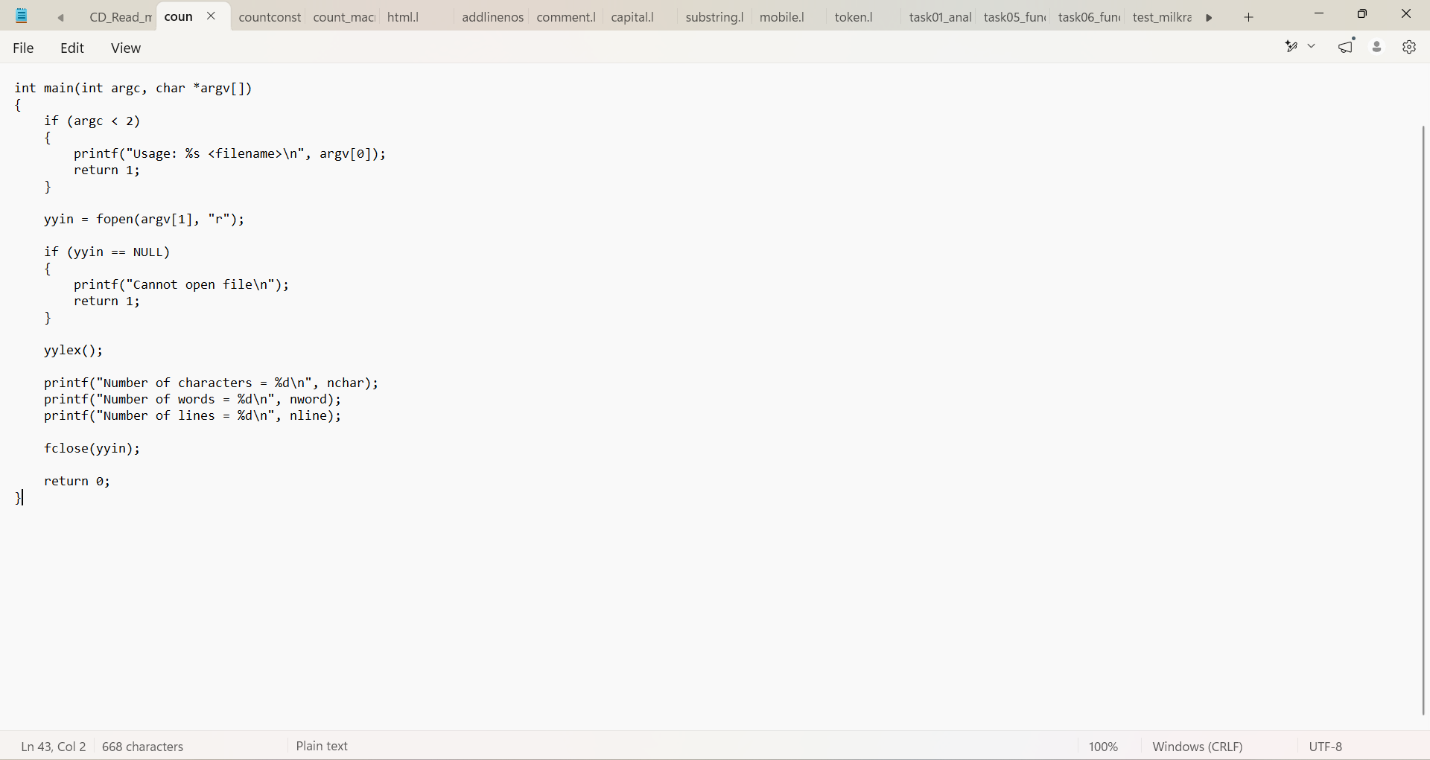

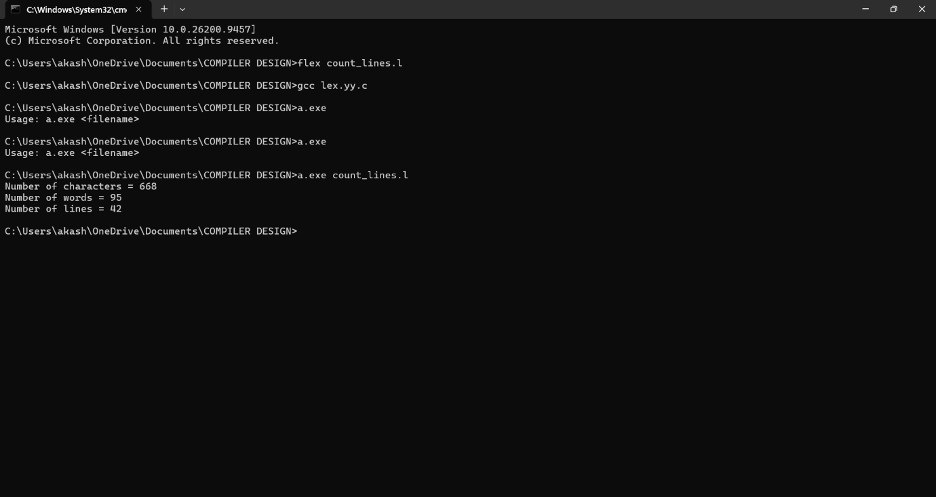

Exp. No. 22
Write a LEX program to print all the constants in the given C source program file.

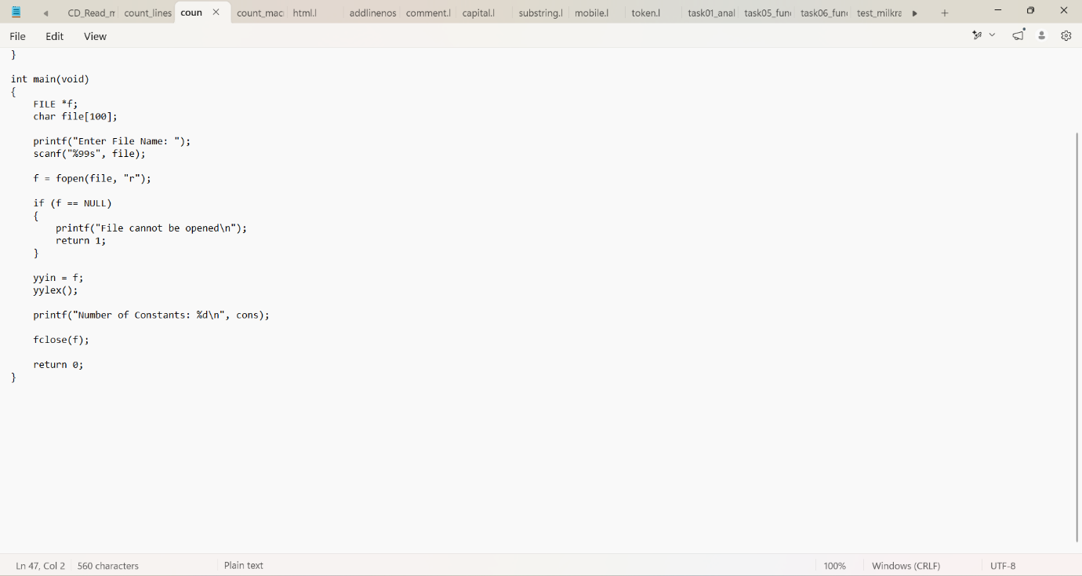

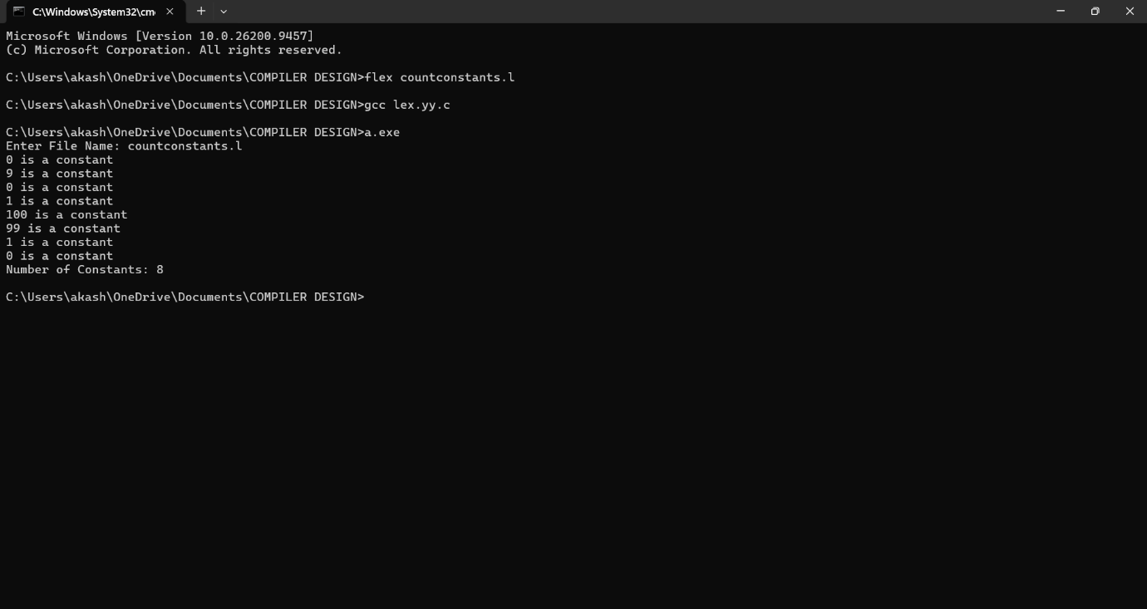

Exp. No. 23
Write a LEX program to count the number of Macros defined and header files included in the C program.

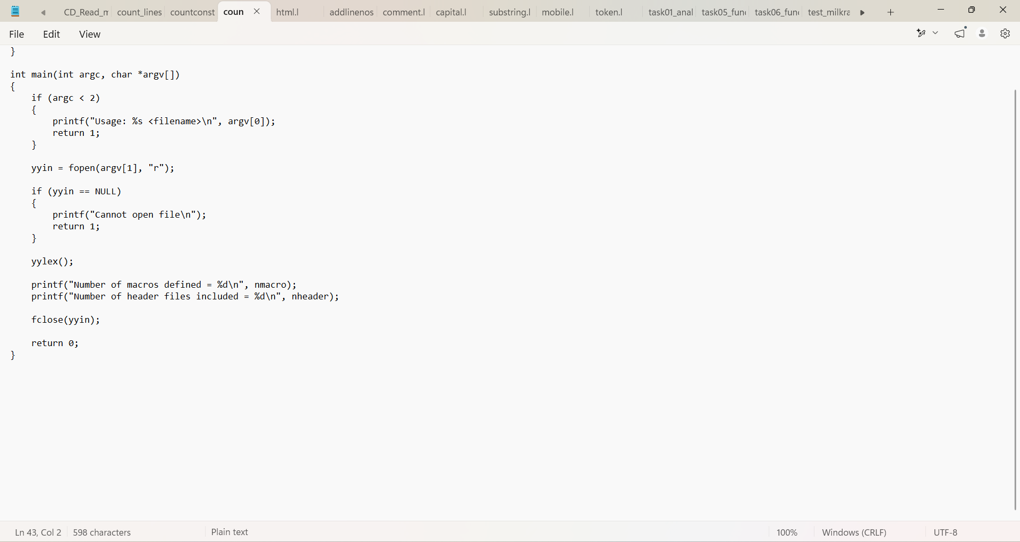

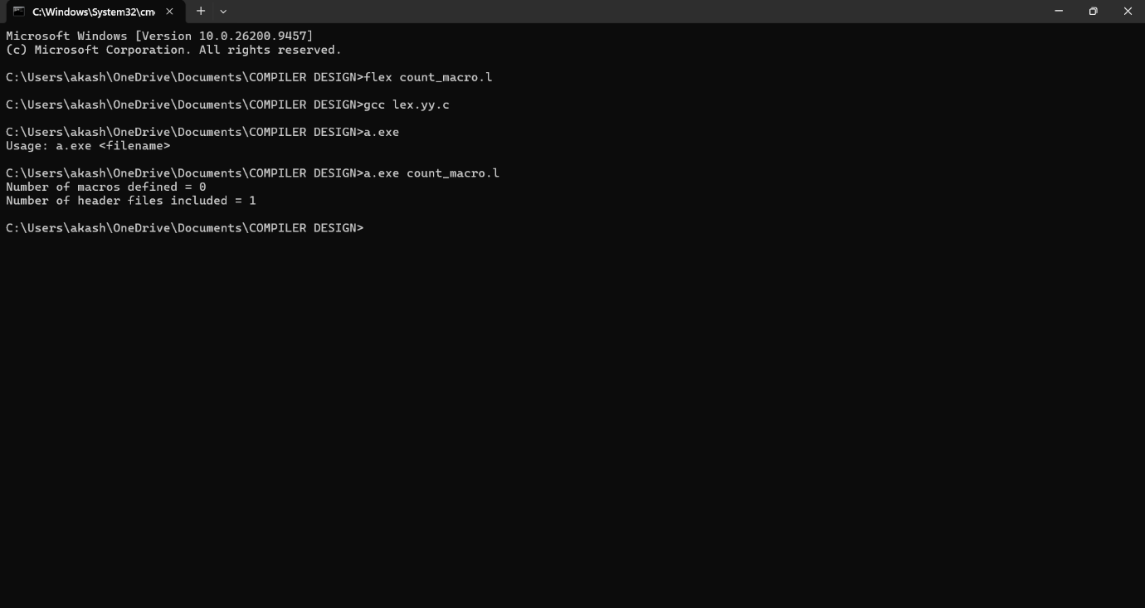

Exp. No. 24
Write a LEX program to print all HTML tags in the input file. 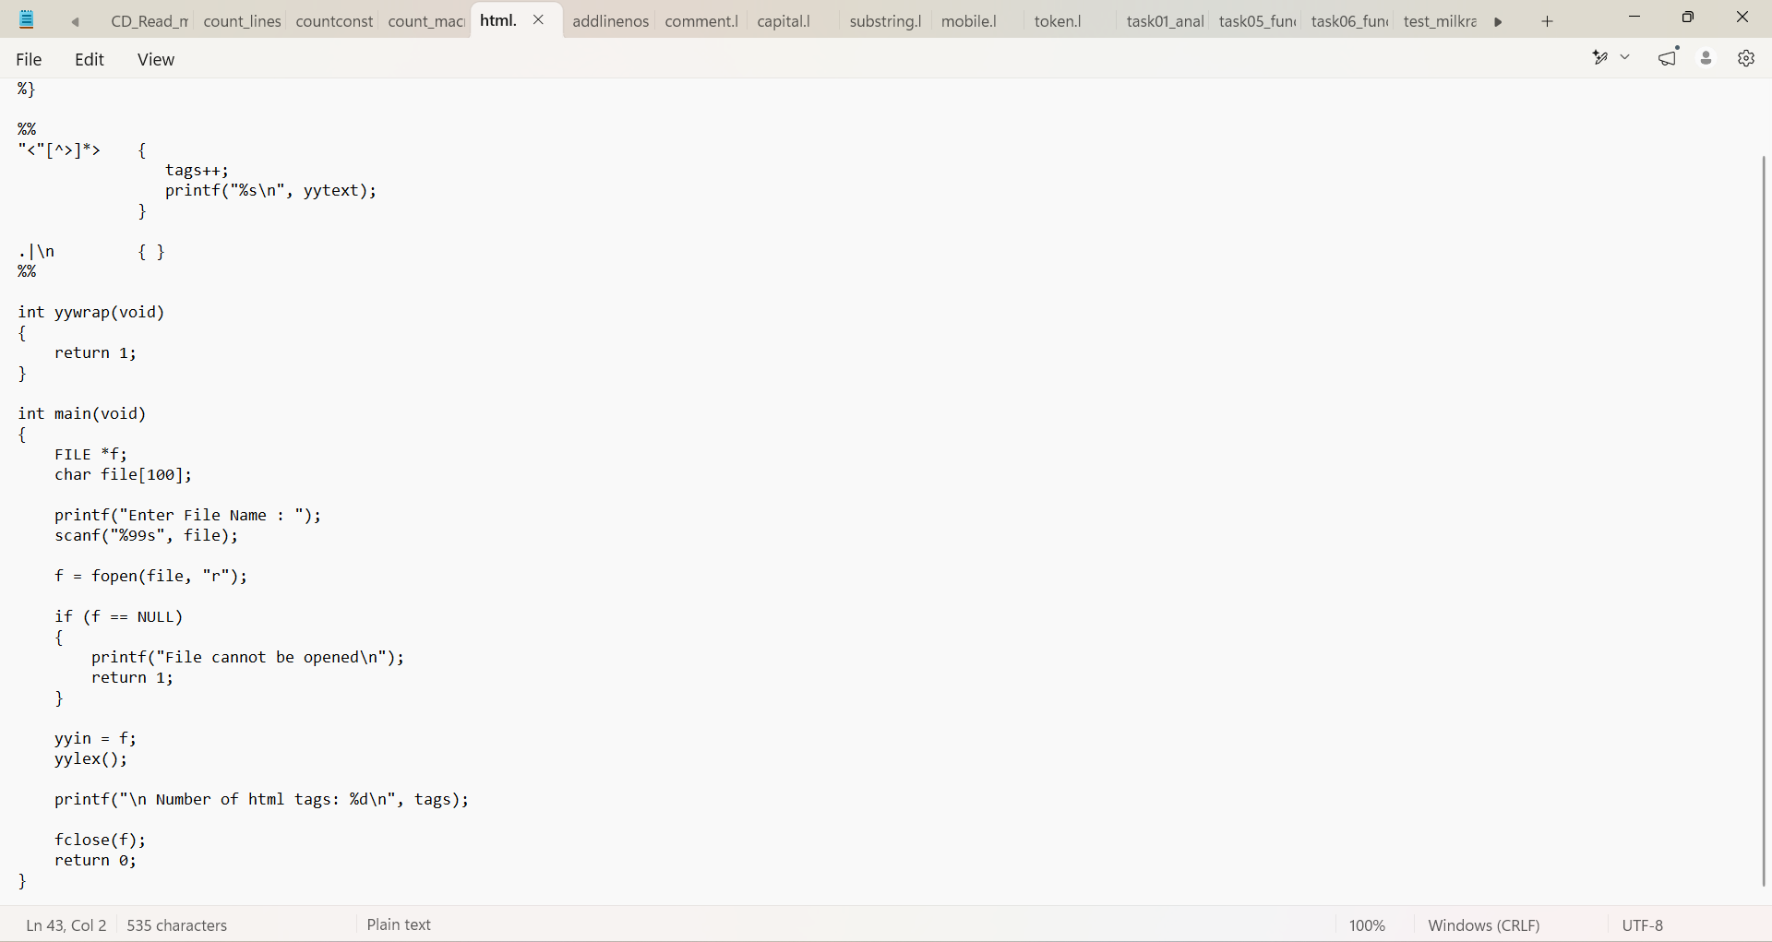

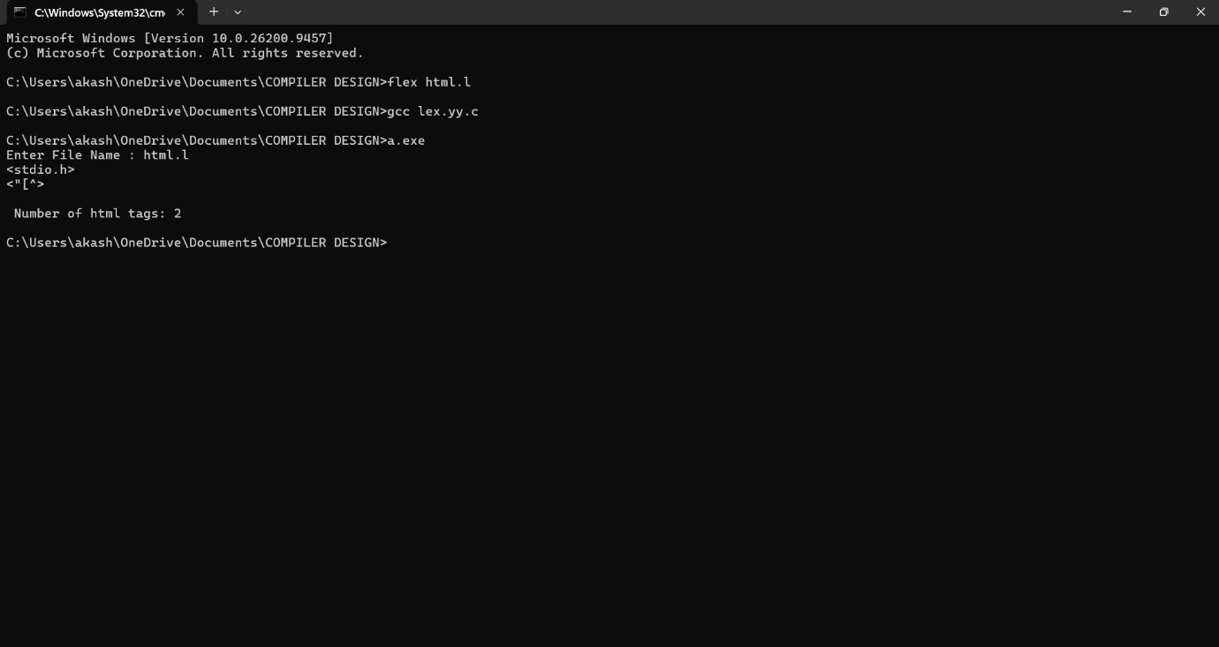

Exp. No. 25
Write a LEX program which adds line numbers to the given C program file and display the same in the standard output.

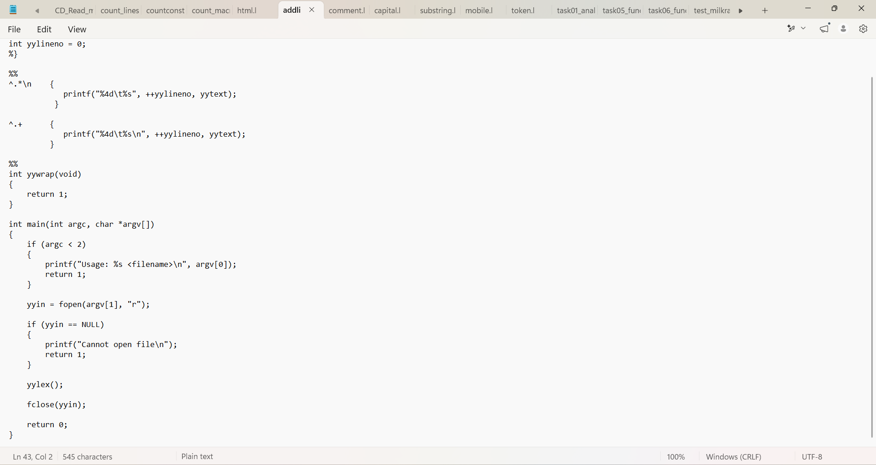

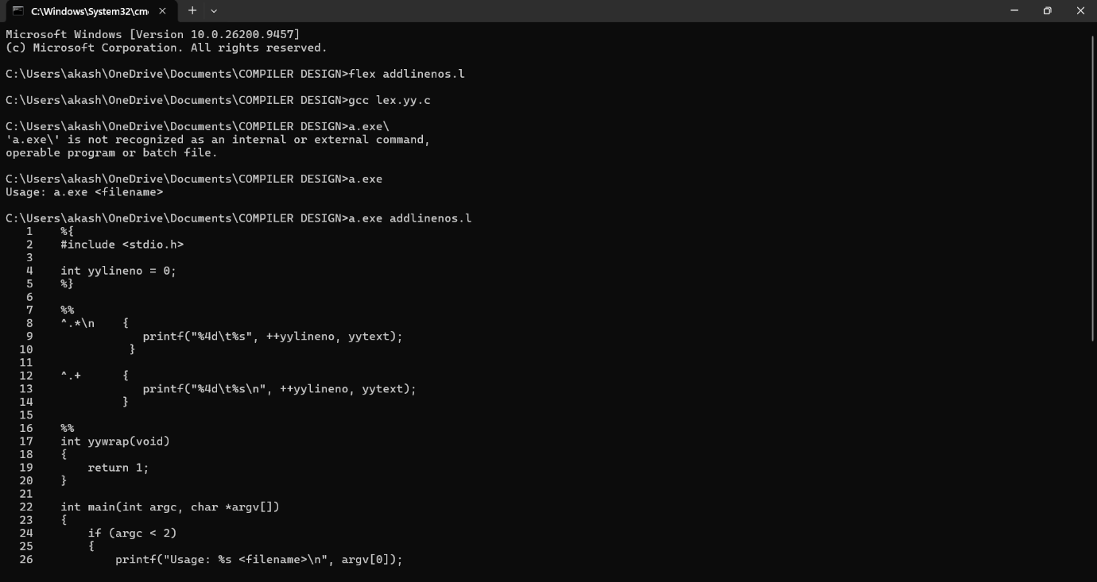

Exp. No. 26
Write a LEX program to count the number of comment lines in a given C program and eliminate them and write into another file.
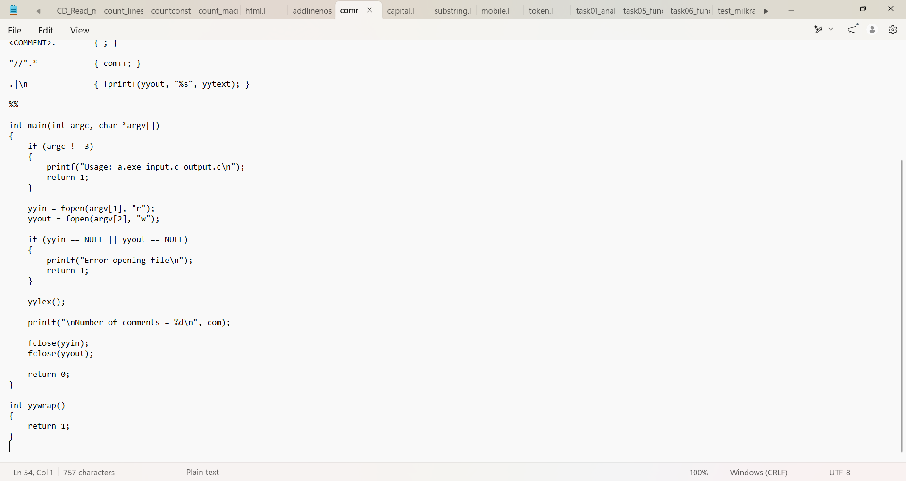

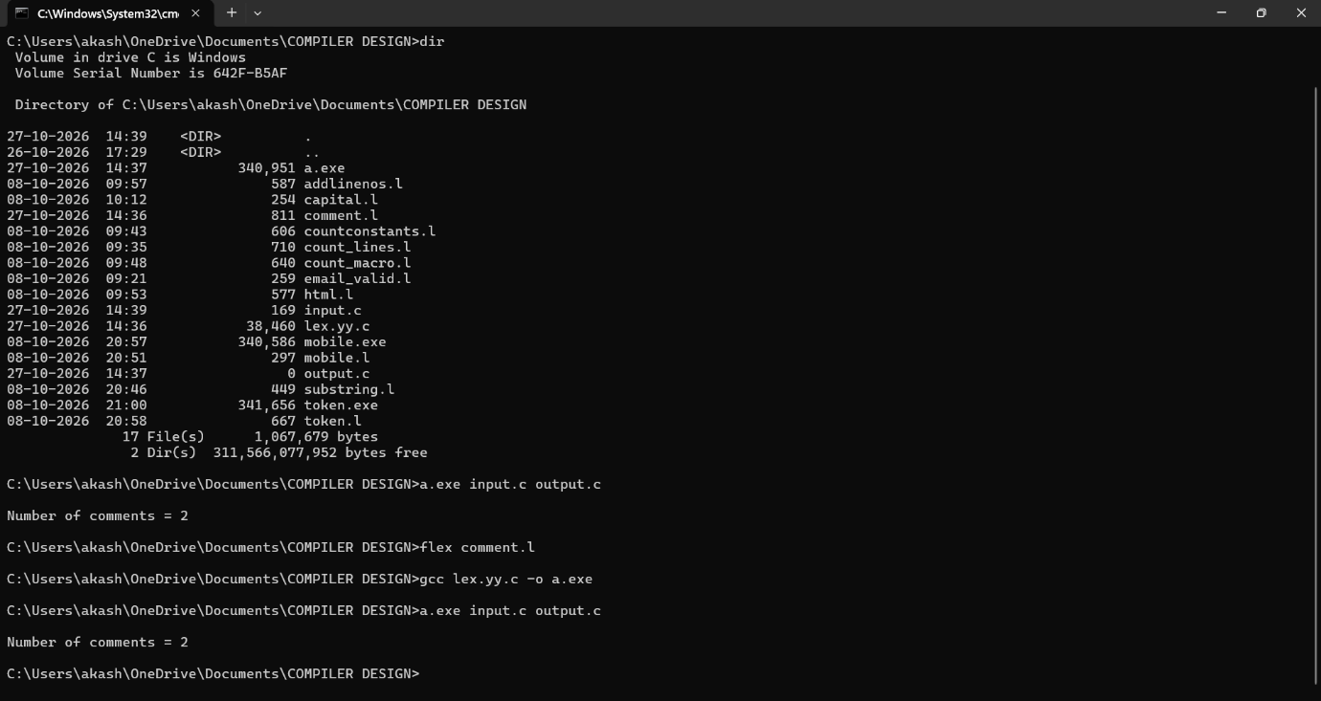

Exp. No. 27
Write a LEX program to identify the capital words from the given input.

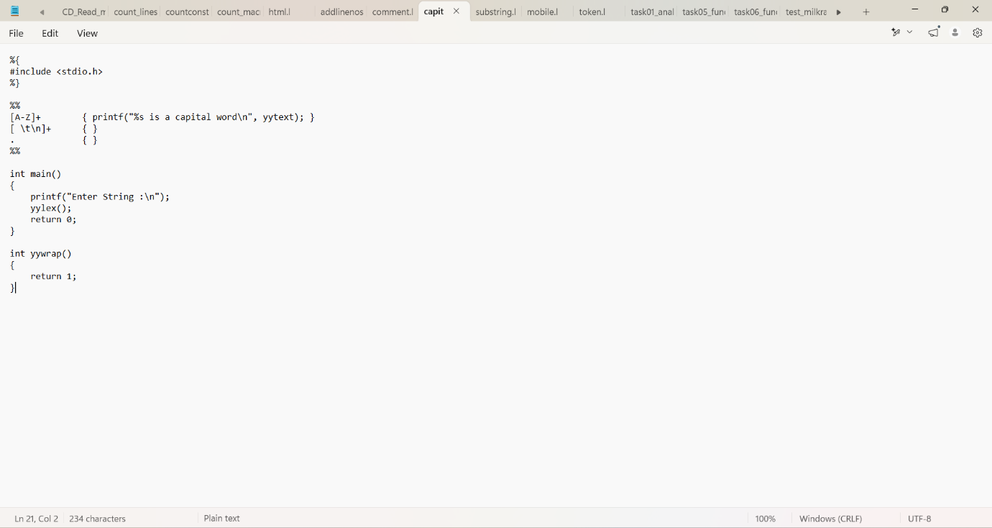
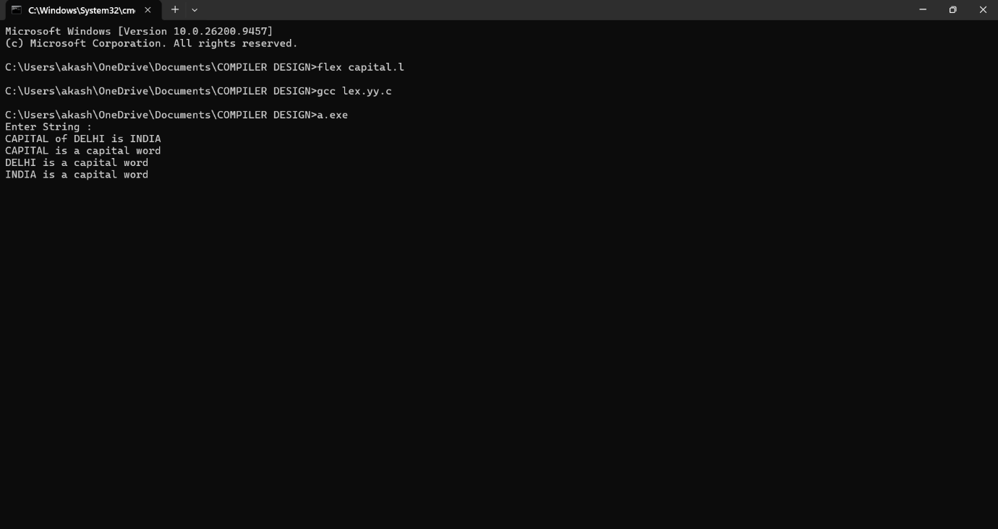

Exp. No. 28
Write a LEX Program to check the email address is valid or not.
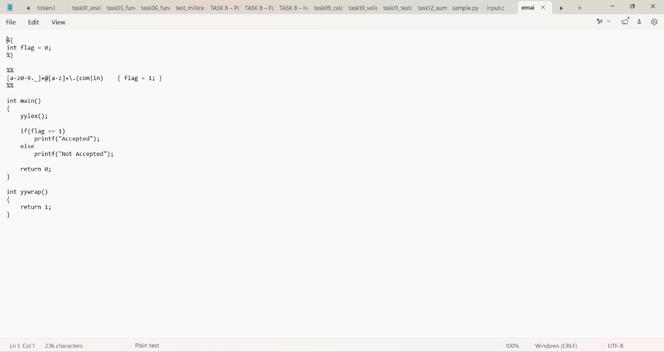

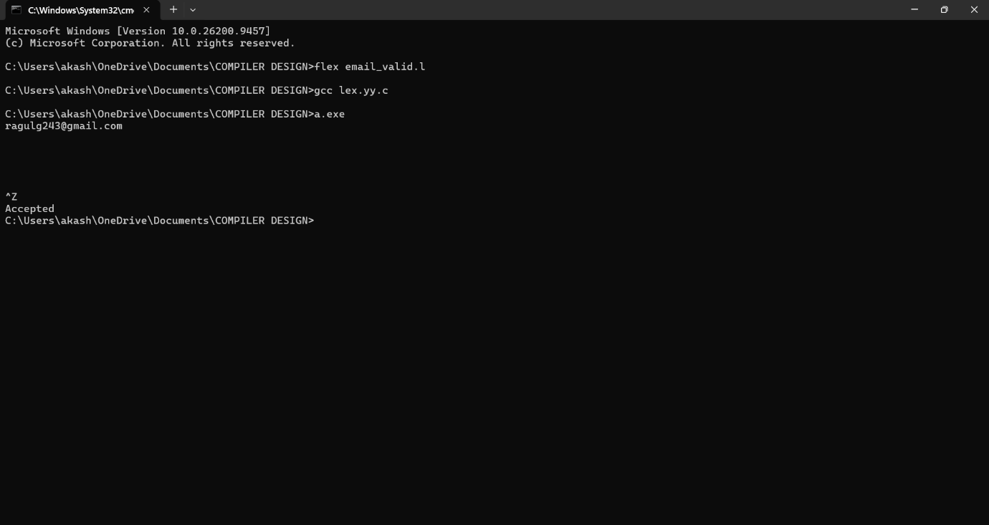

Exp. No. 29
Write a LEX Program to convert the substring abc to ABC from the given input string

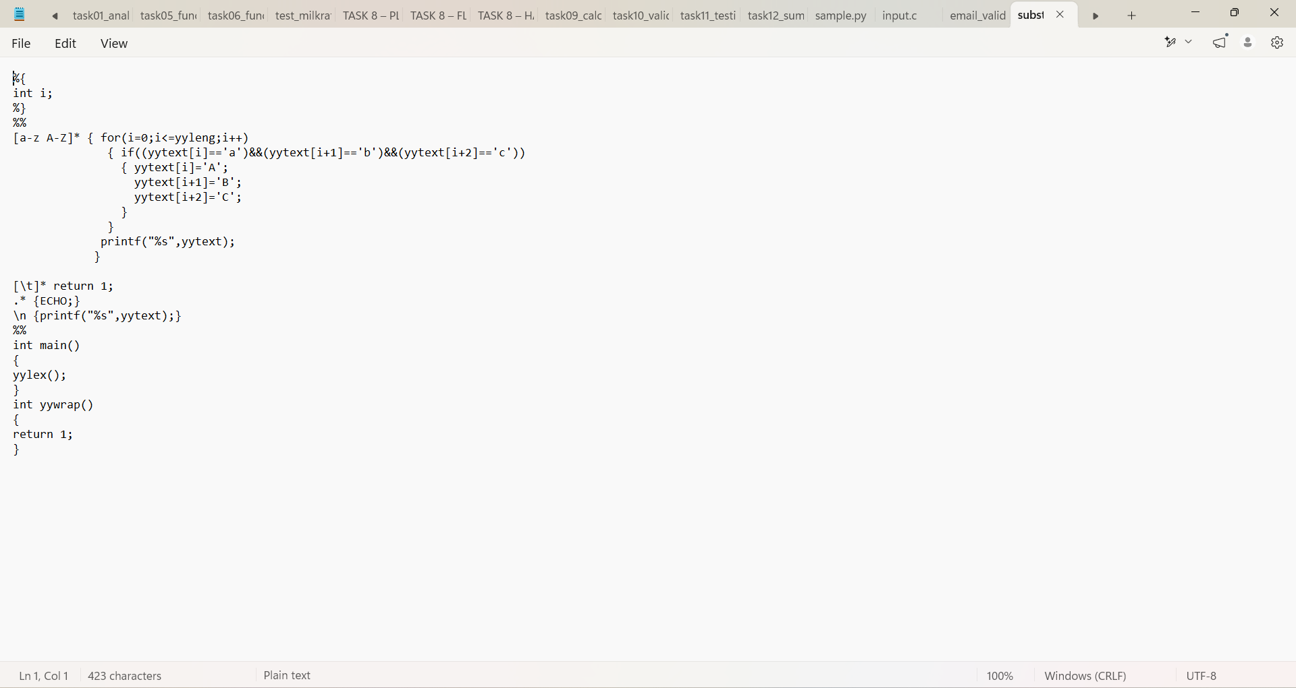

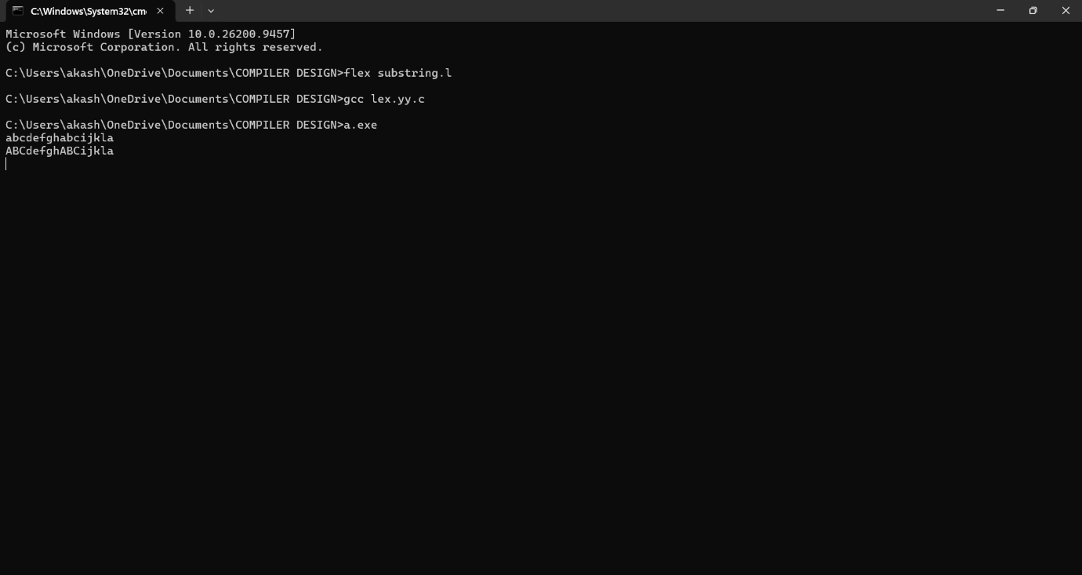

Exp. No. 30
Implement a LEX program to check whether the mobile number is valid or not
